FINGERPRINT RECOGNITION BASED ELECTRONIC VOTING MACHINE
ABSTRACT
The objective of voting is to allow voters to exercise their right to express their choices regarding specific issues, pieces of legislation, citizen initiatives, constitutional amendments, recalls and/or to choose their government and political representatives. It has always been an onerous task for the election commission to conduct free and fair polls in our country, the largest democracy in the world. A lot of money has been spent on this to make sure that the elections are rampage free. But, now- a -days it has become very usual for some forces to indulge in rigging which may eventually lead to a result contrary to the actual verdict given by the people. In order to provide inexpensive solutions to the above, this project will be implemented with biometric system i.e. finger print scanning. This is used to ensure the security to avoid fake, repeated voting etc. It also enhances the accuracy and speed of the process. The system uses thumb impression for voter identification as we know that the thumb impression of every human being has a unique pattern. Thus it would have an edge over the present day voting systems. The purpose of such system is to ensure that the voting rights are accessed only by a legitimate user and no one else. In this, creation of a database consisting of the thumb impressions of all the eligible voters in a constituency is done as a pre-poll procedure. During elections, the thumb impression of a voter is entered as input to the system. This is then compared with the available records in the database. If the particular pattern matches with any one in the available record, access to cast a vote is granted. But in case the pattern doesn’t match with the records of the database or in case of repetition, access to cast a vote is denied or the vote gets rejected. The result is instantaneous and counting is done. The overall cost for conducting elections gets reduced and so does the maintenance cost of the systems.

INTRODUCTION
Biometrics is the science and technology of measuring and analyzing biological data. In information technology, biometrics refers to technologies that measure and analyze human body characteristics, such as DNA, fingerprints, eye retinas and irises, voice patterns, facial patterns and hand measurements, for authentication purposes. In this paper we have used thumb impression for the purpose of voter identification or authentication. As the thumb impression of every individual is unique, it helps in maximizing the accuracy. A database is created containing the thumb impressions of all the voters in the constituency. Illegal votes and repetition of votes is checked for in this system. Hence if this system is employed the elections would be fair and free from rigging. Thanks to this system that conducting elections would no longer be a tedious and expensive job.

EXISTING SYSTEM
Electronic Voting Machines ("EVM"), Idea mooted by the Chief Election Commissioner in 1977. The EVMs were devised and designed by Election Commission of India in collaboration with Bharat Electronics Limited (BEL), Bangalore and Electronics Corporation of India Limited (ECIL), Hyderabad. The EVMs are now manufactured by the above two undertakings. An EVM consists of two units, i) Control Unit, ii) Balloting Unit. The two units are joined by a five-meter cable. The Control Unit is with the Presiding Officer or a Polling Officer and the Balloting Unit is placed inside the voting compartment.
There are two types of problems with EVM which is currently in use :
- Security Problems - One can change the program installed in the EVM and tamper the results after the polling. By replacing a small part of the machine with a look-alike component that can be silently instructed to steal a percentage of the votes in favor of a chosen candidate. These instructions can be sent wirelessly from a mobile phone.
- Illegal Voting (Rigging) - The very commonly known problem, Rigging which is faced in every electoral procedure. One candidate casts the votes of all the members or few amounts of members in the electoral list illegally. This results in the loss of votes for the other candidates participating and also increases the number votes to the candidate who performs this action. This can be done externally at the time of voting.

MODULE DESCRIPTION
4.1 Power Supply
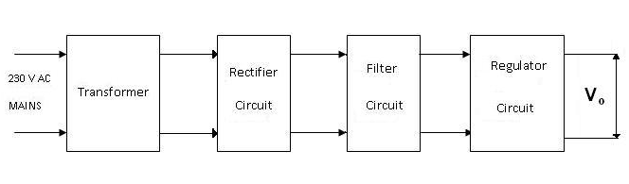
The given block diagram includes following:
Transformer: A transformer is an electromagnetic static device, which transfers electrical energy from one circuit to another, either at the same voltage or at different voltage but at the same frequency.
Rectifier: The function of the rectifier is to convert AC to DC current or voltage. Usually in the rectifier circuit full wave bridge rectifier is used.

Filter: The Filter is used to remove the pulsated AC. A filter circuit uses capacitor and inductor. The function of the capacitor is to block the DC voltage and bypass the AC voltage. The function of the inductor is to block the AC voltage and bypass the DC voltage.
Voltage Regulator: Voltage regulator constitutes an indispensable part of the power supply section of any electronic systems. The main advantage of the regulator ICs is that it regulates or maintains the output constant, in spite of the variation in the input supply.

4.2 MICROCONTROLLER – ATMEGA 8A
• High-performance, Low-power AVR 8-bit Microcontroller
• Advanced RISC Architecture
  - 130 Powerful Instructions – Most Single-clock Cycle Execution
  - 32 x 8 General Purpose Working Registers
  - Fully Static Operation
  - Up to 16 MIPS Throughput at 16 MHz
  - On-chip 2-cycle Multiplier
• High Endurance Non-volatile Memory segments
  - 8K Bytes of In-System Self-programmable Flash program memory
  - 512 Bytes EEPROM
  - 1K Byte Internal SRAM
  - Write/Erase Cycles: 10,000 Flash/100,000 EEPROM
  - Data retention: 20 years at 85°C/100 years at 25°C
  - Optional Boot Code Section with Independent Lock Bits
  - In-System Programming by On-chip Boot Program
  - True Read-While-Write Operation
  - Programming Lock for Software Security
• Peripheral Features
  - Two 8-bit Timer/Counters with Separate pre scalar, one Compare Mode
  - One 16-bit Timer/Counter with Separate Pre scalar, Compare Mode, and Capture Mode.
  - Real Time Counter with Separate Oscillator
  - Three PWM Channels
  - 8-channel ADC in TQFP and QFN/MLF package
  - Eight Channels 10-bit Accuracy
  - 6-channel ADC in PDIP package
  - Six Channels 10-bit Accuracy
  - Byte-oriented Two-wire Serial Interface
  - Programmable Serial USART
  - Master/Slave SPI Serial Interface
  - Programmable Watchdog Timer with Separate On-chip Oscillator
  - On-chip Analog Comparator
• Special Microcontroller Features
- Power-on Reset and Programmable Brown-out Detection
- Internal Calibrated RC Oscillator
- External and Internal Interrupt Sources
- Five Sleep Modes: Idle, ADC Noise Reduction, Power-save, Power-down, and Standby.
• I/O and Packages
- 23 Programmable I/O Lines
- 28-lead PDIP, 32-lead TQFP, and 32-pad QFN/MLF
• Operating Voltages
- 2.7 - 5.5V (ATmega8L)
- 4.5 - 5.5V (ATmega8)
• Speed Grades
- 0 - 8 MHz (ATmega8L)
- 0 - 16 MHz (ATmega8)
• Power Consumption at 4 MHz. 3V, 25°C
- Active: 3.6 mA
- Idle Mode: 1.0 mA
- Power-down Mode: 0.5 µA

4.3 Pin Configurations
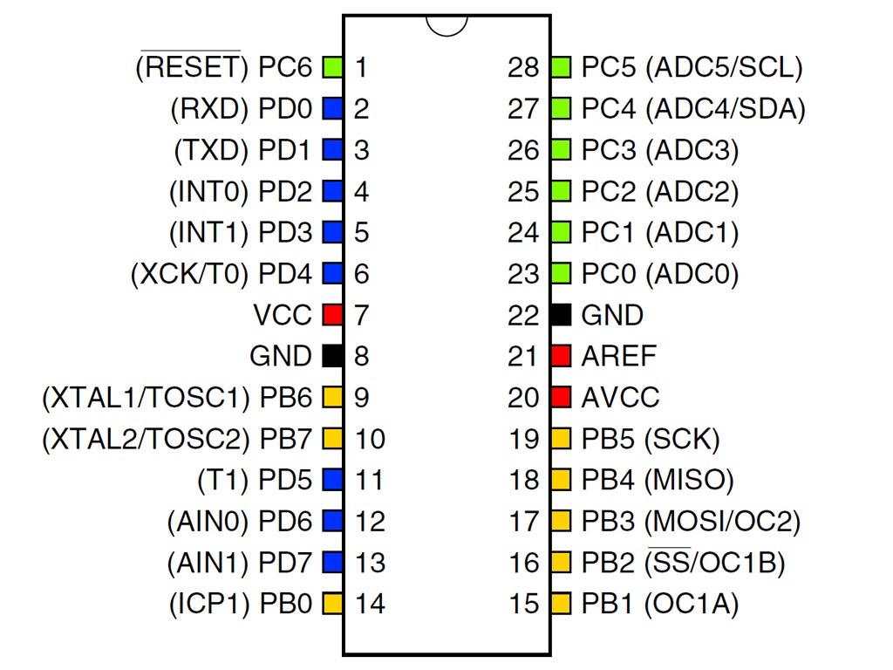

4.4 Pin Descriptions
VCC - Digital supply voltage.
GND - Ground.
Port B (PB7-PB0)
XTAL1/XTAL2/TOSC1/TOSC2
Port B is an 8-bit bi-directional I/O port with internal pull-up resistors (selected for each bit). The Port B output buffers have symmetrical drive characteristics with both high sink and source capability. As inputs, Port B pins that are externally pulled low will source current if the pull-up resistors are activated. The Port B pins are tri-stated when a reset condition becomes active, even if the clock is not running. Depending on the clock selection, fuse settings, PB6 can be used as input to the inverting Oscillator amplifier and input to the internal clock operating circuit. Depending on the clock selection fuse settings, PB7 can be used as output from the inverting Oscillator amplifier. If the Internal Calibrated RC Oscillator is used as chip clock source, PB7-6 is used as TOSC2-1 input for the Asynchronous Timer/Counter2 if the AS2 bit in ASSR is set.
Port C (PC5.PC0)
Port C is an 7-bit bi-directional I/O port with internal pull-up resistors (selected for each bit). The Port C output buffers have symmetrical drive characteristics with both high sink and source capability. As inputs, Port C pins that are externally pulled low will source current if the pull-up resistors are activated. The Port C pins are tri-stated when a reset condition becomes active, even if the clock is not running.
PC6/RESET
If the RSTDISBL Fuse is programmed, PC6 is used as an I/O pin. Note that the electrical characteristics of PC6 differ from those of the other pins of Port C. If the RSTDISBL Fuse is un programmed, PC6 is used as a Reset input. A low level on this pin for longer than the minimum pulse length will generate a Reset, even if the clock is not running. Shorter pulses are not guaranteed to generate a Reset.
Port D (PD7.PD0)
Port D is an 8-bit bi-directional I/O port with internal pull-up resistors (selected for each bit). The Port D output buffers have symmetrical drive characteristics with both high sink and source capability. As inputs, Port D pins that are externally pulled low will source current if the pull-up resistors are activated. The Port D pins are tri-stated when a reset condition becomes active, even if the clock is not running.

RESET
Reset input. A low level on this pin for longer than the minimum pulse length will generate a reset, even if the clock is not running. Shorter pulses are not guaranteed to generate a reset.

AVCC
AVCC is the supply voltage pin for the A/D Converter, Port C (3-0), and ADC (7-6). It should be externally connected to VCC, even if the ADC is not used. If the ADC is used, it should be connected to VCC through a low-pass filter. Note that Port C (5.4) use digital supply voltage, VCC.
AREF
AREF is the analog reference pin for the A/D Converter.
4.6 LCD
A liquid crystal display (LCD) is a thin, flat display device made up of any number of color or monochrome pixels arrayed in front of a light source or reflector. Each pixel consists of a column of liquid crystal molecules suspended between two transparent electrodes, and two polarizing filters, the axes of polarity of which are perpendicular to each other. Without the liquid crystals between them, light passing through one would be blocked by the other. The liquid crystal twists the polarization of light entering one filter to allow it to pass through the other.
Fig 4.6 Pin Diagram of LCD

4.7 Pin configuration
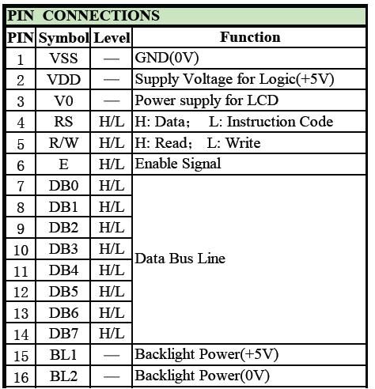

4.9 MAX 232
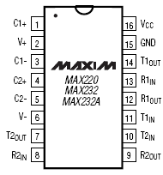
Fig4.3: Pin diagram of MAX232
The MAX220–MAX249 family of line drivers/receivers is intended for all EIA/TIA-232E and V.28/V.24 communications interfaces, particularly applications where ±12V is not available. These parts are especially useful in battery-powered systems, since their low-power shutdown mode reduces power dissipation to less than 5μW.

4.10 RS 232
Due to its relative simplicity and low hardware overhead (as compared to parallel interfacing), serial communications is used extensively within the electronics industry. Today, the most popular serial communications standard in use is certainly the EIA/TIA–232–E specification. This standard, which has been developed by the Electronic Industry Association and the Telecommunications Industry Association (EIA/TIA), is more popularly referred to simply as “RS–232” where “RS” stands for “recommended standard”. In recent years, this suffix has been replaced with “EIA/TIA” to help identify the source of the standard. We use the common notation “RS–232”.
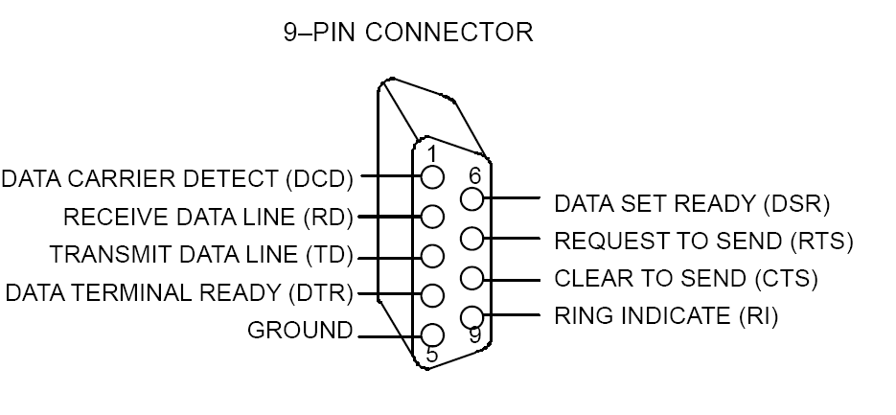
Fig 4.4 DB-9 Connector

CHAPTER 5
SOFTWARE
5.1 SOFTWARE
Code Vision AVR
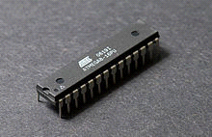

Atmel ATmega8 in 28-pin narrow DIP
The AVR is a modified Harvard architecture 8-bit RISC single chip microcontroller which was developed by Atmel in 1996. The AVR was one of the first microcontroller families to use on-chip flash memory for program storage, as opposed to one-time programmable ROM, EPROM, or EEPROM used by other microcontrollers at the time.
Device overview
The AVR is a modified Harvard architecture machine where program and data are stored in separate physical memory systems that appear in different address spaces, but having the ability to read data items from program memory using special instructions.
Basic families
AVRs are generally classified into five broad groups:
- tinyAVR — the ATtiny series
- 0.5–8 kB program memory
- 6–32-pin package
- Limited peripheral set
- megaAVR — the ATmega series
- 4–256 kB program memory
- 28–100-pin package
- Extended instruction set (Multiply instructions and instructions for handling larger program memories)
- Extensive peripheral set
- XMEGA — the ATxmega series
- 16–384 kB program memory
- 44–64–100-pin package (A4, A3, A1)
- Extended performance features, such as DMA, "Event System", and cryptography support.
- Extensive peripheral set with DACs
- Application-specific AVR
- megaAVRs with special features not found on the other members of the AVR family, such as LCD controller, USB controller, advanced PWM, CAN etc.
- FPSLIC™ (AVR with FPGA)
- FPGA 5K to 40K gates
- SRAM for the AVR program code, unlike all other AVRs
- AVR core can run at up to 50 MHz ^{[5]}
- 32-bit AVRs
Main article: AVR32
In 2006 Atmel released microcontrollers based on the new, 32-bit, AVR32 architecture. They include SIMD and DSP instructions, along with other audio and video processing features. This 32-bit family of devices is intended to compete with the ARM based processors. The instruction set is similar to other RISC cores, but is not compatible with the original AVR or any of the various ARM cores.
Device architecture
Flash, EEPROM, and SRAM are all integrated onto a single chip, removing the need for external memory in most applications. Some devices have a parallel external bus option to allow adding additional data memory or memory-mapped devices. Almost all devices (except the smallest TinyAVR chips) have serial interfaces, which can be used to connect larger serial EEPROMs or flash chips.
Program memory
Program instructions are stored in non-volatile flash memory. Although the MCUs are 8-bit, each instruction takes one or two 16-bit words.
The size of the program memory is usually indicated in the naming of the device itself (e.g., the ATmega64x line has 64 kB of flash while the ATmega32x line has 32 kB).
There is no provision for off-chip program memory; all code executed by the AVR core must reside in the on-chip flash. However, this limitation does not apply to the AT94 FPSLIC AVR/FPGA chips.
Internal data memory
The data address space consists of the register file, I/O registers, and SRAM.
Internal registers
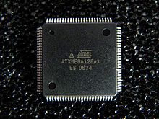
Atmel ATxmega128A1 in 100-pin TQFP package
The AVRs have 32 single-byte registers and are classified as 8-bit RISC devices.
In most variants of the AVR architecture, the working registers are mapped in as the first 32 memory addresses (0000₁₆–001F₁₆) followed by the 64 I/O registers (0020₁₆–005F₁₆).
Actual SRAM starts after these register sections (address 0060₁₆). (Note that the I/O register space may be larger on some more extensive devices, in which case the memory mapped I/O registers will occupy a portion of the SRAM address space.)
Even though there are separate addressing schemes and optimized opcodes for register file and I/O register access, all can still be addressed and manipulated as if they were in SRAM.
In the XMEGA variant, the working register file is not mapped into the data address space; as such, it is not possible to treat any of the XMEGA's working registers as though they were SRAM. Instead, the I/O registers are mapped into the data address space starting at the very beginning of the address space. Additionally, the amount of data address space dedicated to I/O registers has grown substantially to 4096 bytes (0000₁₆–0FFF₁₆). As with previous generations, however, the fast I/O manipulation instructions can only reach the first 64 I/O register locations (the first 32 locations for bitwise instructions). Following the I/O registers, the XMEGA series sets aside a 4096 byte range of the data address space which can be used optionally for mapping the internal EEPROM to the data address space (1000₁₆–1FFF₁₆). The actual SRAM is located after these ranges, starting at 2000₁₆.
EEPROM
Almost all AVR microcontrollers have internal EEPROM for semi-permanent data storage. Like flash memory, EEPROM can maintain its contents when electrical power is removed.
In most variants of the AVR architecture, this internal EEPROM memory is not mapped into the MCU's addressable memory space. It can only be accessed the same way an external peripheral device is, using special pointer registers and read/write instructions which makes EEPROM access much slower than other internal RAM.
However, some devices in the SecureAVR (AT90SC) family ^{[6]} use a special EEPROM mapping to the data or program memory depending on the configuration. The XMEGA family also allows the EEPROM to be mapped into the data address space.
Since the number of writes to EEPROM is not unlimited — Atmel specifies 100,000 write cycles in their datasheets — a well designed EEPROM write routine should compare the contents of an EEPROM address with desired contents and only perform an actual write if contents need to be changed.
Program execution
Atmel's AVRs have a two stage, single level pipeline design. This means the next machine instruction is fetched as the current one is executing. Most instructions take just one or two clock cycles, making AVRs relatively fast among the eight-bit microcontrollers.
The AVR family of processors were designed with the efficient execution of compiled C code in mind and has several built-in pointers for the task.
Instruction set
Main article: Atmel AVR instruction set
The AVR Instruction Set is more orthogonal than those of most eight-bit microcontrollers, in particular the 8051 clones and PIC microcontrollers with which AVR competes today. However, it is not completely regular:
- Pointer registers X, Y, and Z have addressing capabilities that are different from each other.
- Register locations R0 to R15 have different addressing capabilities than register locations R16 to R31.
- I/O ports 0 to 31 have different addressing capabilities than I/O ports 32 to 63.
- CLR affects flags, while SER does not, even though they are complementary instructions. CLR set all bits to zero and SER sets them to one. (Note that CLR is pseudo-op for EOR R, R; and SER is short for LDI R,$FF. Math operations such as EOR modify flags while moves/loads/stores/branches such as LDI do not.)
- Accessing read-only data stored in the program memory (flash) requires special LPM instructions; the flash bus is otherwise reserved for instruction memory.
Additionally, some chip-specific differences affect code generation. Code pointers (including return addresses on the stack) are two bytes long on chips with up to 128 kBytes of flash memory, but three bytes long on larger chips; not all chips have hardware multipliers; chips with over 8 kBytes of flash have branch and call instructions with longer ranges; and so forth.
The mostly-regular instruction set makes programming it using C (or even Ada) compilers fairly straightforward. GCC has included AVR support for quite some time, and that support is widely used. In fact, Atmel solicited input from major developers of compilers for small microcontrollers, to determine the instruction set features that were most useful in a compiler for high-level languages.
MCU speed
The AVR line can normally support clock speeds from 0-20 MHz, with some devices reaching 32 MHz. Lower powered operation usually requires a reduced clock speed. All recent (Tiny, Mega, and Xmega, but not 90S) AVRs feature an on-chip oscillator, removing the need for external clocks or resonator circuitry. Some AVRs also have a system clock prescaler that can divide down the system clock by up to 1024. This prescaler can be reconfigured by software during run-time, allowing the clock speed to be optimized.
Since all operations (excluding literals) on registers R0 - R31 are single cycle, the AVR can achieve up to 1 MIPS per MHz, i.e. an 8 MHz processor can achieve up to 8 MIPS. Loads and stores to/from memory take 2 cycles, branching takes 2 cycles. Branches in the latest "3-byte PC" parts such as ATmega2560 are one cycle slower than on previous devices.
Development
AVRs have a large following due to the free and inexpensive development tools available, including reasonably priced development boards and free development software. The AVRs are sold under various names that share the same basic core but with different peripheral and memory combinations. Compatibility between chips in each family is fairly good, although I/O controller features may vary.
Features
Current AVRs offer a wide range of features:
- Multifunction, bi-directional general-purpose I/O ports with configurable, built-in pull-up resistors
- Multiple internal oscillators, including RC oscillator without external parts
- Internal, self-programmable instruction flash memory up to 256 kB (384 kB on XMega)
- In-system programmable using serial/parallel low-voltage proprietary interfaces or JTAG
- Optional boot code section with independent lock bits for protection
- On-chip debugging (OCD) support through JTAG or debugWIRE on most devices
- The JTAG signals (TMS, TDI, TDO, and TCK) are multiplexed on GPIOs. These pins can be configured to function as JTAG or GPIO depending on the setting of a fuse bit, which can be programmed via ISP or HVSP. By default, AVRs with JTAG come with the JTAG interface enabled.
- debugWIRE uses the /RESET pin as a bi-directional communication channel to access on-chip debug circuitry. It is present on devices with lower pin counts, as it only requires one pin.
- Internal data EEPROM up to 4 kB
- Internal SRAM up to 16 kB (32 kB on XMega)
- External 64 kB little endian data space on certain models, including the Mega8515 and Mega162.
- The external data space is overlaid with the internal data space, such that the full 64 kB address space does not appear on the external bus. An accesses to e.g. address 0100₁₆ will access internal RAM, not the external bus.
- In certain members of the XMega series, the external data space has been enhanced to support both SRAM and SDRAM. As well, the data addressing modes have been expanded to allow up to 16 MB of data memory to be directly addressed.
- AVRs generally do not support executing code from external memory. Some ASSPs using the AVR core do support external program memory.
- 8-bit and 16-bit timers
- PWM output (some devices have an enhanced PWM peripheral which includes a dead-time generator)
- Input capture
- Analog comparator
- 10 or 12-bit A/D converters, with multiplex of up to 16 channels
- 12-bit D/A converters
- A variety of serial interfaces, including
- I²C compatible Two-Wire Interface (TWI)
- Synchronous/asynchronous serial peripherals (UART/USART) (used with RS-232, RS-485, and more)
- Serial Peripheral Interface Bus (SPI)
- Universal Serial Interface (USI) for two or three-wire synchronous data transfer
- Brownout detection
- Watchdog timer (WDT)
- Multiple power-saving sleep modes
- Lighting and motor control (PWM-specific) controller models
- CAN controller support
- USB controller support
- Proper full-speed (12 Mbit/s) hardware & Hub controller with embedded AVR.
- Also freely available low-speed (1.5 Mbit/s) (HID) bitbanging software emulations
- Ethernet controller support
- LCD controller support
- Low-voltage devices operating down to 1.8 V (to 0.7 V for parts with built-in DC–DC upconverter)
- picoPower devices
- DMA controllers and "event system" peripheral communication.
- Fast cryptography support for AES and DES
Programming interfaces
There are many means to load program code into an AVR chip. The methods to program AVR chips varies from AVR family to family.
ISP
The In-system programming (ISP) programming method is functionally performed through SPI, plus some twiddling of the Reset line. As long as the SPI pins of the AVR aren't connected to anything disruptive, the AVR chip can stay soldered on a PCB while reprogramming. All that's needed is a 6-pin connector and programming adapter. This is the most common way to develop with an AVR.
The Atmel AVR ISP mkII device connects to a computer's USB port and performs in-system programming using Atmel's software.
AVRDUDE (AVR Downloder UploaDEr) runs on Linux, FreeBSD, Windows, and Mac OS X, and supports a variety of in-system programming hardware, including Atmel AVR ISP mkII, Atmel JTAG ICE, older Atmel serial-port based programmers, and various third-party and "do-it-yourself" programmers.^{[7]}
PDI
The Program and Debug Interface (PDI) is an Atmel proprietary interface for external programming and on-chip debugging of XMEGA devices. The PDI supports high-speed programming of all non-volatile memory (NVM) spaces; flash, EEPROM, fuses, lock-bits and the User Signature Row. This is done by accessing the XMEGA NVM controller through the PDI interface, and executing NVM controller commands. The PDI is a 2-pin interface using the Reset pin for clock input (PDI_CLK) and a dedicated data pin (PDI_DATA) for input and output.^{[8]}
High voltage
High-voltage serial programming (hvsp)^{[9]} is mostly the backup mode on smaller AVRs. An 8-pin AVR package doesn't leave many unique signal combinations to place the AVR into a programming mode. A 12 volt signal, however, is something the AVR should only see during programming and never during normal operation.
Parallel
Parallel programming is considered the "final resort" and may be the only way to fix AVR chips with bad fuse settings. Parallel programming may be faster and beneficial when programming many AVR devices for production use.
Bootloader
Most AVR models can reserve a bootloader region, 256 B to 4 KB, where re-programming code can reside. At reset, the bootloader runs first, and does some user-programmed determination whether to re-program, or jump to the main application. The code can re-program through any interface available, it could read an encrypted binary through an Ethernet adapter like PXE. Atmel has application notes and code pertaining to many bus interfaces.^{[10]}[11][12][13]
ROM
The AT90SC series of AVRs are available with a factory mask-ROM rather than flash for program memory.^{[14]} Because of the large up-front cost and minimum order quantity, a mask-ROM is only cost-effective for high production runs.
aWire
aWire is a new one-wire debug interface available on the new UC3L AVR32 devices.
Debugging interfaces
The AVR offers several options for debugging, mostly involving on-chip debugging while the chip is in the target system.
debugWIRE
debugWIRETM is Atmel's solution for providing on-chip debug capabilities via a single microcontroller pin. It is particularly useful for lower pin count parts which cannot provide the four "spare" pins needed for JTAG. The JTAGICE mkII, mkIII and the AVR Dragon support debugWIRE. debugWIRE was developed after the original JTAGICE release, and now clones support it.
JTAG
JTAG provides access to on-chip debugging functionality while the chip is running in the target system.^{[15]} JTAG allows accessing internal memory and registers, setting breakpoints on code, and single-stepping execution to observe system behaviour.
Atmel provides a series of JTAG adapters for the AVR:
- The JTAGICE 3 is the latest member of the JTAGICE family (JTAGICE mkIII). It supports JTAG, aWire, SPI, and PDI interfaces.
- The JTAGICE mkII replaces the JTAGICE, and is similarly priced. The JTAGICE mkII interfaces to the PC via USB, and supports both JTAG and the newer debugWIRE interface. Numerous 3rd-party clones of the Atmel JTAGICE mkII device started shipping after Atmel released the communication protocol.^{[16]}
- The AVR Dragon is a low-cost (approximately $50) substitute for the JTAGICE mkII for certain target parts. The AVR Dragon provides in-system serial programming, high-voltage serial programming and parallel programming, as well as JTAG or debugWIRE emulation for parts with 32 KB of program memory or less. ATMEL changed the debugging feature of AVR Dragon with the latest firmware of AVR STUDIO 4 - AVR STUDIO 5 and now it supports devices over 32KB of program memory.
- The JTAGICE adapter interfaces to the PC via a standard serial port. The JTAGICE has been End-Of-Lifed, though it is still supported in AVR Studio and other tools.
JTAG can also be used to perform a Boundary Scan test,^{[17]} which tests the electrical connections between AVRs and other Boundary Scan capable chips in a system. Boundary scan is well-suited for a production line; the hobbyist is probably better off testing with a multimeter or oscilloscope.
Development tools and evaluation kits
Official Atmel AVR development tools and evaluation kits consists of a number of starter kits and debugging tools with support for most AVR devices:
STK600 starter kit
The STK600 starter kit and development system is an update to the STK500.^{[18]} The STK600 uses a base board, a signal routing board, and a target board.
The base board is similar to the STK500, in that it provides a power supply, clock, in-system programming, an RS-232 port and a CAN (Controller Area Network, an automotive standard) port via DB9 connectors, and stake pins for all of the GPIO signals from the target device.
The target boards have ZIF sockets for DIP, SOIC, QFN, or QFP packages, depending on the board.
The signal routing board sits between the base board and the target board, and routes the signals to the proper pin on the device board. There are many different signal routing boards that could be used with a single target board, depending on what device is in the ZIF socket.
The STK600 interfaces with the PC via USB, leaving the RS-232 port available for the target microcontroller. A 4 pin header on the STK600 labeled 'RS-232 spare' can connect any TTL level USART port on the chip to the onboard MAX232 chip. The MAX232 is a TTL to RS-232 signal level converter to communicate with PC's. The pins are RX, TX, CTS, and RTS.
STK500 starter kit
The STK500 starter kit and development system features ISP and high voltage programming (HVP) for all AVR devices, either directly or through extension boards. The board is fitted with DIP sockets for all AVRs available in DIP packages.
STK500 Expansion Modules: Several expansion modules are available for the STK500 board:
- STK501 - Adds support for microcontrollers in 64-pin TQFP packages.
- STK502 - Adds support for LCD AVRs in 64-pin TQFP packages.
- STK503 - Adds support for microcontrollers in 100-pin TQFP packages.
- STK504 - Adds support for LCD AVRs in 100-pin TQFP packages.
- STK505 - Adds support for 14 and 20-pin AVRs.
- STK520 - Adds support for 14 and 20, and 32-pin microcontrollers from the AT90PWM and ATmega family.
- STK524 - Adds support for the ATmega32M1/C1 32-pin CAN/LIN/Motor Control family.
- STK525 - Adds support for the AT90USB microcontrollers in 64-pin TQFP packages.
- STK526 - Adds support for the AT90USB microcontrollers in 32-pin TQFP packages
STK200 starter kit
The STK200 starter kit and development system can use AVR chips via DIL-40/20/8 and features 4 MHz clock source, 8x Light-emitting diodes, 8x input buttons, RS-232 port, option for 32k SRAM and numerous general I/O. Programmed can be done with a dongle connected to the parallel-port and the ISP socket.
Software wise programs can be compiled with avr-gcc, Simulated with simulavr, Downloaded with avrdude/avrice on BSD and Linux. Assembler is available with avra/tpasm. GNU debugger is available with avr-gdb.
Support microcontrollers (according to the manual)
Chip | Flash size | EEPROM | SRAM | Frequency  [MHz] | Package
AT90S1200 | 1k | 64 | 0 | 12 | PDIP-20
AT90S2313 | 2k | 128 | 128 | 10 | PDIP-20
AT90S/LS2323 | 2k | 128 | 128 | 10 | PDIP-8
AT90S/LS2343 | 2k | 128 | 128 | 10 | PDIP-8
AT90S4414 | 4k | 256 | 256 | 8 | PDIP-40
AT90S/LS4434 | 4k | 256 | 256 | 8 | PDIP-40
AT90S8515 | 8k | 512 | 512 | 8 | PDIP-40
AT90S/LS8535 | 8k | 512 | 512 | 8 | PDIP-40
AVR ISP and AVR ISP mkII
The AVR ISP and AVR ISP mkII are inexpensive tools allowing all AVRs to be programmed via ICSP.
The AVR ISP connects to a PC via a serial port, and draws power from the target system. The AVR ISP allows using either of the "standard" ICSP pinouts, either the 10-pin or 6-pin connector. The AVR ISP has been discontinued, replaced by the AVR ISP mkII.
The AVR ISP mkII connects to a PC via USB, and draws power from USB. LEDs visible through the translucent case indicate the state of target power.
AVR Dragon
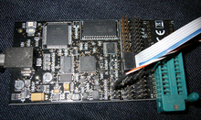
AVR Dragon with ISP programming cable.
The Atmel Dragon is an inexpensive tool which connects to a PC via USB. The Dragon can program all AVRs via JTAG, HVP, PDI^{[19]} , or ICSP. The Dragon also allows debugging of all AVRs via JTAG, PDI, or DebugWire; a previous limitation to devices with 32 kB or less program memory has been removed in AVRstudio 4.18.^{[20]} The Dragon has a small prototype area which can accommodate an 8, 28, or 40-pin AVR, including connections to power and programming pins. There is no area for any additional circuitry, although this can be provided by a third-party product called the "Dragon Rider".
JTAGICE mkI
The JTAG In Circuit Emulator (JTAGICE) debugging tool supports on-chip debugging (OCD) of AVRs with a JTAG interface. The original JTAGICE mkI uses an RS-232 interface to a PC, and can only program AVR's with a JTAG interface. The JTAGICE mkI is no longer in production, however it has been replaced by the JTAGICE mkII.
JTAGICE mkII
The JTAGICE mkII debugging tool supports on-chip debugging (OCD) of AVRs with SPI, JTAG, PDI, and debugWIRE interfaces. The debugWire interface enables debugging using only one pin (the Reset pin), allowing debugging of applications running on low pin-count microcontrollers.
The JTAGICE mkII connects using USB, but there is an alternate connection via serial port, which requires using a separate power supply. In addition to JTAG, the mkII supports ISP programming (using 6-pin or 10-pin adapters). Both the USB and serial links use a variant of the STK500 protocol.
Butterfly demo board
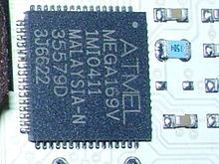
Atmel ATmega169 in 64-pad MLF package.
Main article: AVR Butterfly
The very popular AVR Butterfly demonstration board is a self-contained, battery-powered computer running the Atmel AVR ATmega169V microcontroller. It was built to show-off the AVR family, especially a new built-in LCD interface. The board includes the LCD screen, joystick, speaker, serial port, real time clock (RTC), flash memory chip, and both temperature and voltage sensors. Earlier versions of the AVR Butterfly also contained a CdS photoresistor; it is not present on Butterfly boards produced after June 2006 to allow RoHS compliance.^{[21]} The small board has a shirt pin on its back so it can be worn as a name badge.
The AVR Butterfly comes preloaded with software to demonstrate the capabilities of the microcontroller. Factory firmware can scroll your name, display the sensor readings, and show the time. The AVR Butterfly also has a piezo speaker that can be used to reproduce sounds and music.
The AVR Butterfly demonstrates LCD driving by running a 14-segment, six alpha-numeric character display. However, the LCD interface consumes many of the I/O pins.
The Butterfly's ATmega169 CPU is capable of speeds up to 8 MHz, however it is factory set by software to 2 MHz to preserve the button battery life. A pre-installed bootloader program allows the board to be re-programmed via a standard RS-232 serial plug with new programs that users can write with the free Atmel IDE tools.
AT90USBKey
This small board, about half the size of a business card, is priced at slightly more than an AVR Butterfly. It includes an AT90USB1287 with USB On-The-Go (OTG) support, 16 MB of DataFlash, LEDs, a small joystick, and a temperature sensor. The board includes software which lets it act as a USB Mass Storage device (its documentation is shipped on the DataFlash), a USB joystick, and more. To support the USB host capability, it must be operated from a battery; but when running as a USB peripheral, it only needs the power provided over USB.
Only the JTAG port uses conventional 2.54 mm pinout. All the other AVR I/O ports require more compact 1.27 mm headers.
The AVR Dragon can both program and debug since the 32 kb limitation was removed in AVR Studio 4.18, and the JTAGICE mkII is capable of both programming and debugging the processor. The processor can also be programmed through USB from a Windows or Linux host, using the USB "Device Firmware Update" protocols. Atmel ships proprietary (source code included but distribution restricted) example programs and a USB protocol stack with the device.
LUFA is a third-party free software (MIT license) USB protocol stack for the USBKey and other
Raven wireless kit
The RAVEN kit supports wireless development using Atmel's IEEE 802.15.4 chipsets, for ZigBee and other wireless stacks. It resembles a pair of wireless more-powerful Butterfly cards, plus a wireless USBKey; and costing about that much (under $US100). All these boards support JTAG-based development.
The kit includes two AVR Raven boards, each with 2.4 GHz transceiver supporting IEEE 802.15.4 (and a freely licensed ZigBee stack). The radios are driven with ATmega1284p processors, which are supported by a custom segmented LCD display driven by an ATmega3290p processor. Raven peripherals resemble the Butterfly: piezo speaker, DataFlash (bigger), external EEPROM, sensors, 32 kHz crystal for RTC, and so on. These are intended for use in developing remote sensor nodes, to control relays, or whatever is needed.
The USB stick uses an AT90USB1287 for connections to a USB host and to the 2.4 GHz wireless links. These are intended to monitor and control the remote nodes, relying on host power rather than local batteries.
Third-party programmers
A wide variety of third-party programming and debugging tools are available for the AVR. These devices use various interfaces, including RS-232, PC parallel port, and USB. AVR Freaks has a comprehensive list.
Atmel AVR usage
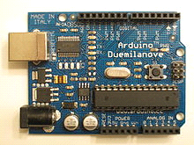
Atmel AVR Atmega328 28-pin DIP on a Arduino Duemilanove board
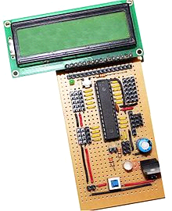
Atmel AVR Atmega8 28-pin DIP on a
custom designed development board
AVRs have been used in various automotive applications such as security, safety, powertrain and entertainment systems. Atmel has recently launched a new publication "Atmel Automotive Compilation" to help developers with automotive applications. Some current usages are in BMW, Daimler-Chrysler and TRW.
The Arduino physical computing platform is based on an ATmega328 microcontroller (ATmega168 or ATmega8 in older board versions than the Diecimila). The ATmega1280 and ATmega2560, with more pinout and memory capabilities, have also been employed to develop the Arduino Mega platform. Arduino boards can be used with its language and IDE, or with more conventional programming environments (C, assembler, etc.) as just standardized and widely available AVR platforms.
USB-based AVRs have been used in the Microsoft Xbox hand controllers. The link between the controllers and Xbox is USB.
Numerous companies produce AVR-based microcontroller boards intended for use by hobbyists, robot builders, experimenters and small system developers including: Cubloc, gnusb, BasicX, Oak Micros, ZX Microcontrollers, and myAVR. There is also a large community of Arduino-compatible boards supporting similar users. Few hobbyists prefer making their own version of board from scratch.
Schneider Electric produces the M3000 Motor and Motion Control Chip, incorporating an Atmel AVR Core and an Advanced Motion Controller for use in a variety of motion applications.^{[22]}
FPGA clones
With the growing popularity of FPGAs among the open source community, people have started developing open source processors compatible with the AVR instruction set. The OpenCores website lists the following major AVR clone projects:
- pAVR, written in VHDL, is aimed at creating the fastest and maximally featured AVR processor, by implementing techniques not found in the original AVR processor such as deeper pipelining.
- avr_core, written in VHDL, is a clone aimed at being as close as possible to the ATmega103.
- Navré, written in Verilog, implements all Classic Core instructions and is aimed at high performance and low resource usage. It does not support interrupts.

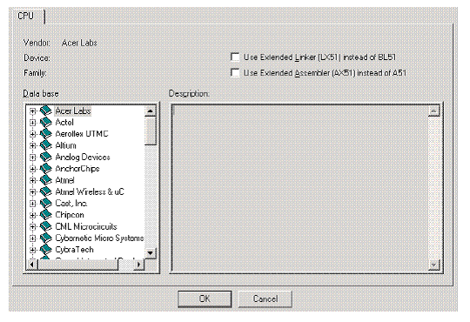
Fig 6.1: Window for choosing target device.

Next, Micro Vision must be instructed to generate a HEX file upon program compilation. A HEX file is a standard file format for storing executable code that is to be loaded onto the microcontroller. In the “Project Workspace” pane at the left, right–click on “Target 1” and select “Options for ‘Target 1’ ”.Under the “Output” tab of the resulting options dialog, ensure that both the “Create Executable” and “Create HEX File” options are checked. Then click “OK”.

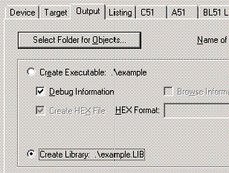
Fig 6.2: Project Options Dialog

Next, a file must be added to the project that will contain the project code. To do this, expand the “Target 1” heading, right–click on the “Source Group 1” folder, and select “Add files…” Create a new blank file (the file name should end in “.asm”), select it, and click “Add.” The new file should now appear in the “Project Workspace” pane under the “Source Group 1” folder. Double-click on the newly created file to open it in the editor. All code for this lab will go in this file. To compile the program, first save all source files by clicking on the “Save All” button, and then click on the “Rebuild All Target Files” to compile the program as shown in the figure below. If any errors or warnings occur during compilation, they will be displayed in the output window at the bottom of the screen. All errors and warnings will reference the line and column number in which they occur along with a description of the problem so that they can be easily located. Note that only errors indicate that the compilation failed, warnings do not (though it is generally a good idea to look into them anyway).

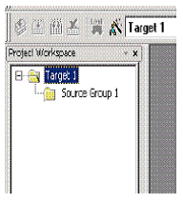
Fig 6.3: Project Workspace Pane

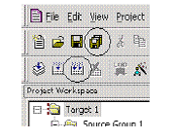
Fig 6.4: “Save All” and “Build All Target Files” Buttons

At the left side of the debugger window, a table is displayed containing several key parameters about the simulated microcontroller, most notably the elapsed time (circled in the figure below). Just above that, there are several buttons that control code execution. The “Run” button will cause the program to run continuously until a breakpoint is reached, whereas the “Step Into” button will execute the next line of code and then pause (the current position in the program is indicated by a yellow arrow to the left of the code).

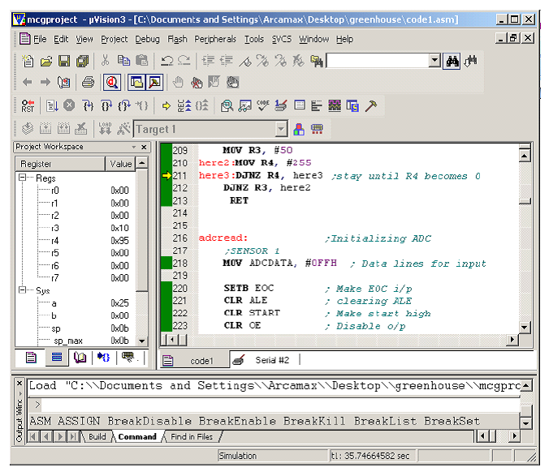
Fig 6.5: μVision3 Debugger window

